True Love: A Work of Art
Rabbi Shlomo Buxbaum
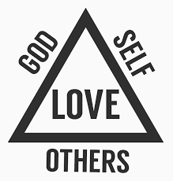
What 4 words would you pick that defines/describes love?
1. ______________________________
2.______________________________
3.______________________________
4. ______________________________

Torah sources for love:

- The world is built on loving-kindness (Psalms 89:3)
- Love your neighbor like yourself (Vaykira 19:18)
- And you shall love Hashem, with all your Lev (heart), with all your Nefesh (soul), and with all your Me’od (money or portion).(Devarim 6:5)
- A man shall leave his father and his mother, and cleave to his wife, and they shall become one flesh. (Bereishit 2:24)
- Now the man knew his wife Eve, and she conceived (Bereishit 4:1)
- Honor your father and your mother (Shemot 20:12)
- Man shall have awe his mother and his father, (Vayikra 19:3)

ה | ב | ה | א | 13= | ד | ח | א
5 | 2 | 5 | 1 |  | 4 | 8 | 1
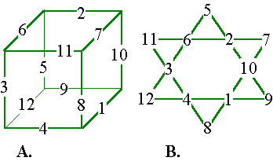

Grow Your Love Worksheet

For the next ________________ I will grow my love for ______________________.
Pick 4 words that describe your definition of love: | On a scale from 1-5, how well are you doing in this area today? | End of set time period. Same question.
1.
2.
3.
4.
With all your Lev (heart): Name 2 ways that you can use your creativity, talent and personal touch to increase your love:

With all your Nefesh (soul): Name 2 areas of your life that you can make greater sacrifice for this person:

With all your Me’od (portion): Name 2 barriers in your relationship with this person that you will choose to overcome/accept and love despite these barriers:

